1. Write a query to retrieve information about the managers – id, full_name, deparment_id and department_name. Select the first 5 deparments ordered by employee_id. Submit your queries using the “MySQL prepare DB and Run Queries” strategy.

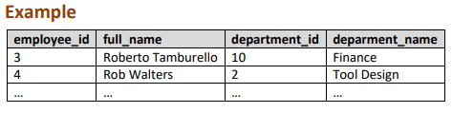

2. Write a query to count the number of employees who receive salary higher than the average. Submit your queries using the “MySQL prepare DB and Run Queries” strategy. 4. Higher Salary Write a query to count the number of employees who receive salary higher than the average. Submit your queries using the “MySQL prepare DB and Run Queries” strategy.